Guest lecture

The project that grabbed my attention the most is a project called “Cash Coach”. This is an ATM-like machine. People (especially students) can fill out a questionnaire and the machine prints a cheque with the amount of money you’re missing out on every month. It is created by a studio called “Vormlust”. They created the Cash Coach in the typical retro style. That is the era that the target group grew up in.

The goal is to raise awareness about the fact that a lot of people are missing out on money. They could, for instance, be eligible for government funds which they might be unaware of. So the goal of this installation is raising awareness, and for the user specifically the goal is to tell them how much more money they could get every month. 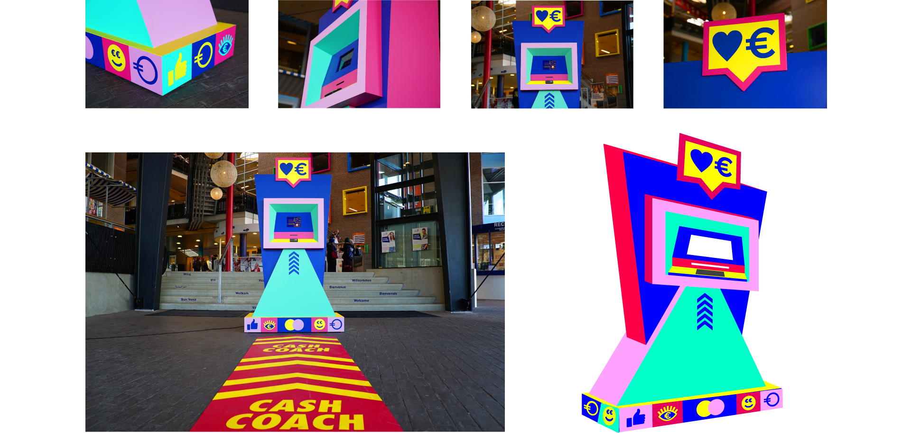

The user fills out a questionnaire about their living situation, what they get paid, how much money their parents make, etc. the computer takes all these factors into account, and checks it with all the funds they might be eligible for. After doing this, it calculates how much money they could get a month, from one or more (government) funds. This amount is printed on a cheque (because it’s shaped like an ATM) and given to the user.

As a touch screen they built an iPad in the installation. Using the touch screen, the users can answer the questions asked by the computer. This project is interesting in the light of the field of HCI, because this is an excellent example of Human Computer Interaction. Something traditionally boring (checking if you’re eligible for (government) funds) is being made fun by creating an old school-style ATM. By interacting with the system you get the information you need in a fun way. This stimulates youth to actually check whether they are eligible for additional funds.

I myself find this especially interesting, because I know so many people who found out way too late that they were eligible for funds from the government. A lot of people don’t know when and how you can get extra money, while a lot of students I know could really use the extra money.